ERwin

Creating Oracle DDL from an ERwin Physical Diagram

NOTE: Before model compare or ddl generation verify the display level by right mouse a white area in the model. Then select display level and set to physical.

- Check out the PHYSICAL ER diagram from PVCS.
- For each table you must select a tablespace. On each table in Erwin, right click on the table, select table editor, physical properties and select the proper tablespace for the table depending on the extent size.
- For each index you must select a tablespace. On each table in Erwin, right click on the table, select ORACLE index, ORACLE, and select the proper a tablespace for the table depending on the extent size.
- The tablespaces will have all of the default values for the tables and indexes.
- Use the Forward engineer / Schema Generation option under the TASKS menu option in ERwin.
- Choose the preview option and save the DDL to a LAN drive directory. Or utilize the generate function to add objects to the database directly. ( Ensure that you are signed on as the table owner. )

Altering a Column on a Table

- Use the Edit Go To function to find the table you are looking for.
- Right Click on table, select Column Editor
- NOTE*** For some changes, like renaming a column, Erwin might generate a drop/create table process. Using a tool like OEM and DBArtisan in this case might allow an alter instead of a drop/create. OEM, for instance, supports the ALTER TABLE RENAME COLUMN statement. Utilizing tools other than Erwin to apply changes to the physical database should always be considered before dropping a table.

Adding a Column on a Table
- Click on the table name, use the tab key to tab to where you want the new column, Press enter , add the new column name, then add the column attributes.
- NOTE*** When adding a new column that is NOT NULL, to avoid having Erwin drop/create the table, temporarily change the column to be NULL in the model. Then, apply the column add to the table (an ALTER TABLE should be generated) and update all rows to populate the new column. Finally, switch the column back to NOT NULL in the model and apply the change to the model. This should generate a ALTER TABLE to change the nullability.

Adding Physical Properties to Objects
For each table
- Determine the owner of the table.
- Put the table in the owners tablespace.
- Remove all other information for the table. ( TS defaults are used )

For each tables indexes.
- Determine the owner of the index
- Put the index in the owners tablespace
- Remove all other information for the index ( TS defaults are used )

Forward Engineering DDL from an ERwin Physical Diagram Options

Physical Properties
Table
- Pctfree standard 20 percent(you can select higher value
Based up updates
- Inittrans standard 5

Index
- Initrans standard 5
- Nologging
- Manually edit generated SQL to use compress option for
Non Unique B-tree Indexes

Schema
None checked
View
None checked (unless
Table
Create Table, Physical Storage
Column
Physical Order
Index
Create Index: Primary Key, Alternate Key, Inversion Entry , Physical Storage
Referential Integrity
Primary Key: Alter/PK
Foreign Key: Alter/FK ( Warehouses and Marts have no FK RI.
Trigger
None Checked
Other options.
Constraint Name, Owner

Erwin Compare Facility.
You can compare a new model to the Database by utilizing the Complete Compare facility in Erwin. When you select the option “ Model Objects Only “ this option will tell you if there is a new object in the model , but it will not tell you if there is an object that was removed from the model. This can be confusing.
When a model changes what should be compared.

Model/Database Compare

-Select from tools
Complete Compare

-Compare Options

Compare Type:
Database level Compare

Compare Current Model With
Database

Sync Action
Upate Current
Select Next

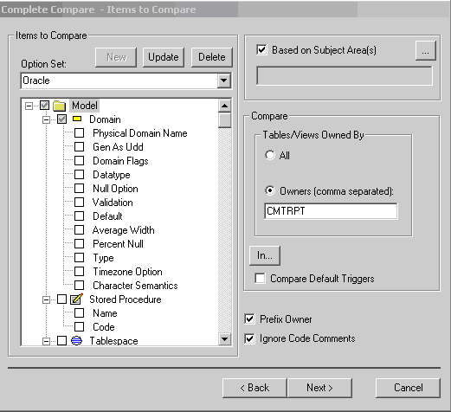
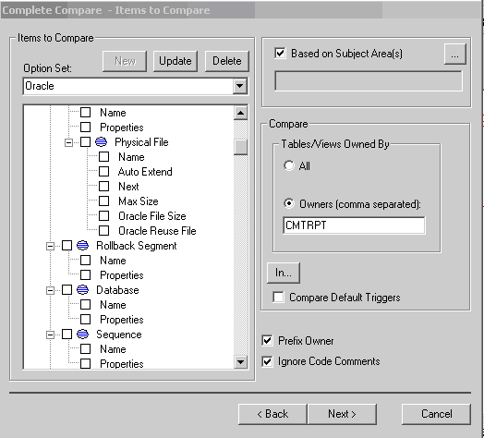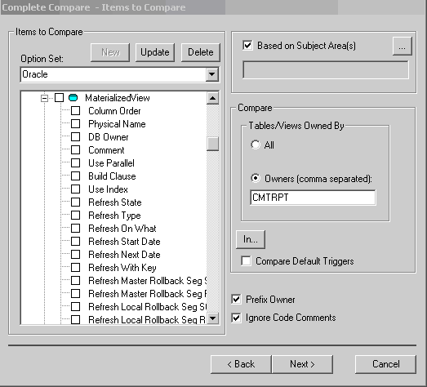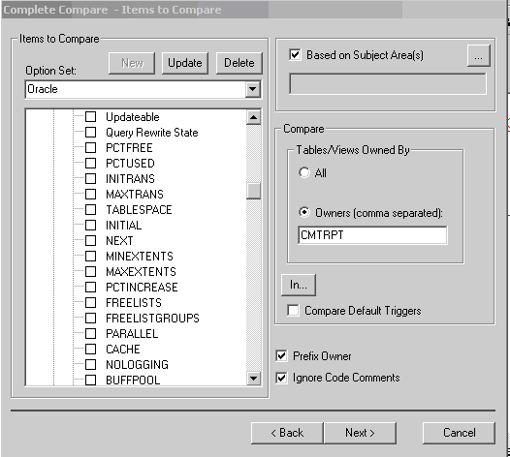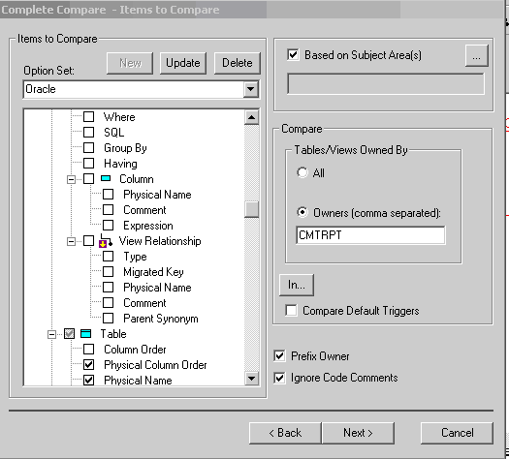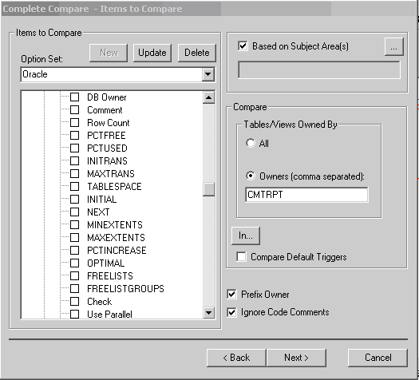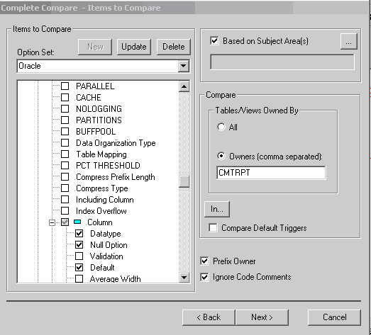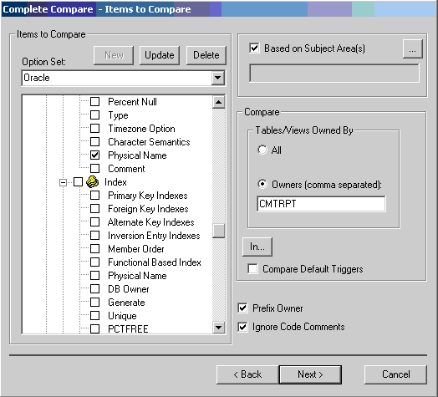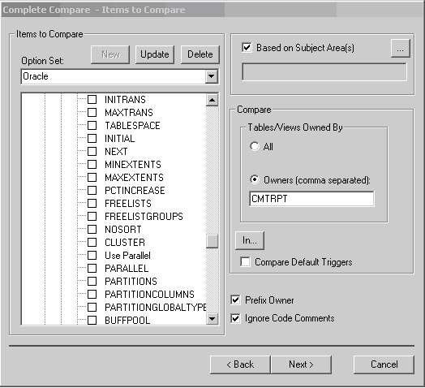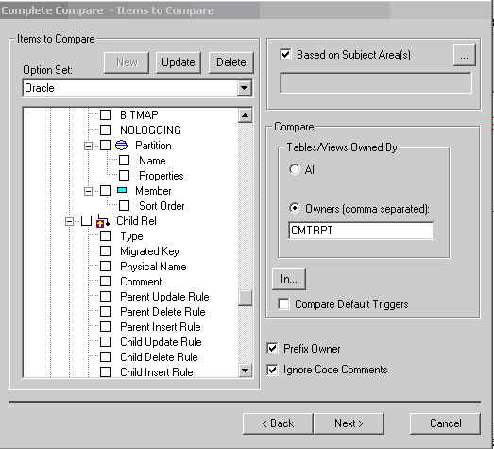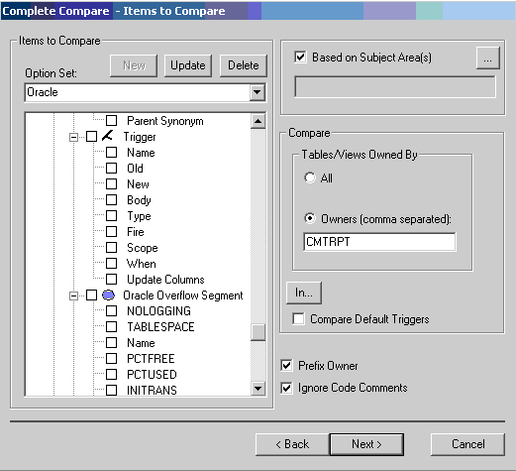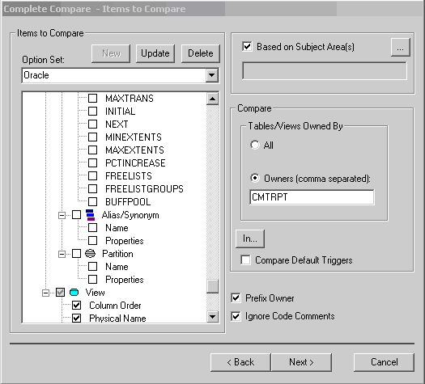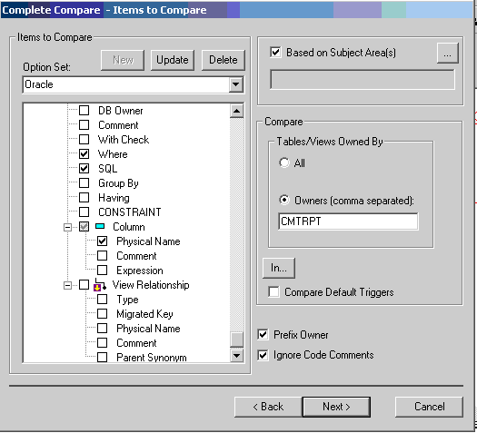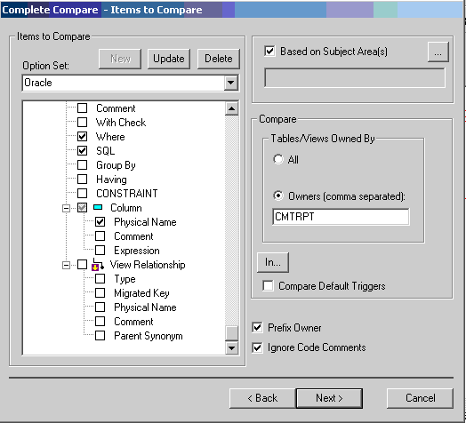
Select Next >

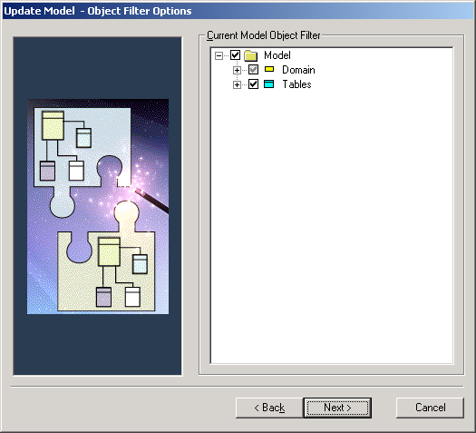

Select Next >

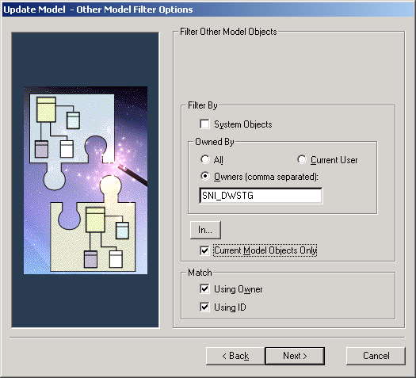

Select Next >

